Ortho-rectification of SWIFT camera images
June 20, 2016
M. Smith, mmsmith@uw.edu

This folder contains Matlab code and an example for the ortho-rectification of images taken from the SWIFT camera at medium resolution. This code is for use on raw, un-rotated images from the v3 SWIFT. Note that this code cannot be applied to frames from timelapse videos in the SWIFT folders. This processing assumes zero pitch and roll (i.e. SWIFT is stationary and vertical), so will be less accurate for moderate and high wave conditions.

Orthorectification code, orthorectifySWIFT_raw.m, calls functions in the image processing and computer vision toolboxes. Intrinsic camera parameters, SWIFT_cam_params.mat, and transformation matrix, transformSWIFT.mat, are loaded and used to undistort and orthorectify image to approximately 1.1x1.5 meter grid in earth reference frame.

Example ortho-rectification:
SWIFT14_PIC_27Oct2015_00_01_01.jpg is SWIFT 14 image from October 27th (pancake ice formation during racetrack loop) at 00:01 UTC. Running orthorectifySWIFT_raw.m gives original image (rotated; left) and orthorectified image on a meter grid (right):

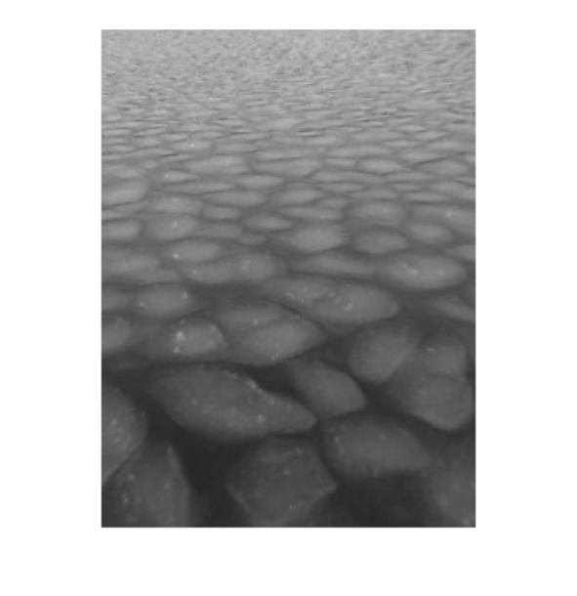
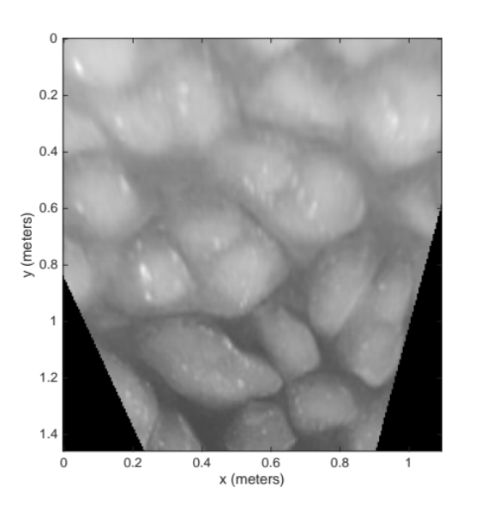

Use of matlab function “imdistline” should allow you to measure feature sizes. In example below, pancake floe length is .43 m or 43 centimeters.
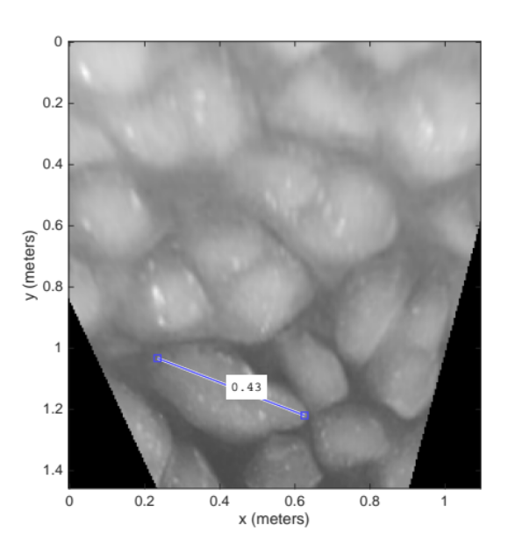

Currently, raw images from “Racetrack” deployments are available on Google Drive Collaboratory in ProcessedData > SWIFTdata_reprocessed > Racetrack. Images for all other SWIFT deployments are available upon request. Please email mmsmith@uw.edu. Timelapse videos of SWIFT camera images from all deployments, located in corresponding folders in SWIFTdata_reprocessed, are useful for determining when SWIFT images might be useful.

